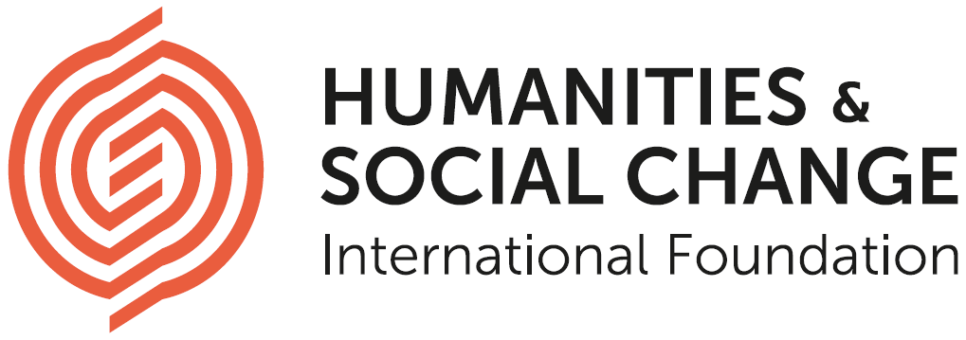

**Interdisciplinary Research Fellow in Economics**

The Humanities and Social Change International Foundation (HSCIF) is looking to hire with immediate effect a Research Fellow in Economics (m/f/x) to support the conceptual and practical development of its new Institute to be established in Hamburg, Germany in 2020. Candidates (m/f/x) with an expertise in Economics (especially in Political Economics, Development Economics, Environmental Economics, Economic History, Industrial Organisation, Economics and Law), Development Studies, Anthropology and Sociology

are encouraged to apply. The main responsibility of the Fellow (m/f/x) will be to create research proposals that link their own academic expertise with the Institute’s overarching objective to develop concrete, innovative concepts for alternative socio-political configurations.

The successful candidate (m/f/x) should have a doctoral degree and some postdoctoral working experience, either at a university, other public institutions or in the private sector. Besides expertise in the above specified fields, the candidate (m/f/x) should demonstrate a strong interest in either Ethics, Environment or Technology. Excellent written English skills are required.

HSCIF was founded in 2016 with the mission to understand the nature of the challenges to society of the 21st century, develop visions and concepts that inspire improvement, and actively promote and influence change. HSC network currently consists of four Research Centers, based respectively at Humboldt University of Berlin; University of California, Santa Barbara; Ca’ Foscari University of Venice; and University of Cambridge. More information about the Foundation and its Centers can be found on [hscif.org](http://hscif.org).

HSCIF is in the process of establishing a new Institute based in Hamburg, and aims to open its doors in fall 2020. The overall objective of the Institute will be the development of concrete, innovative concepts for alternative socio-political configurations, that is addressing the questions of what a future society looks like, how it could function, and how it could be realized. The Institute will form an interdisciplinary and intercultural environment in which academics and thinkers from politics, technology, business, media and the arts will be gathered to thoroughly engage with each other’s ideas and to conduct collaborative research on specified topics.

The post is based in Hamburg, Germany. In the first instance, the position will run for two years, from Spring 2019 to Spring 2021.

To apply send a CV, a cover letter, a research proposal, a written sample of academic work (up to 5,000 words) and 2 reference letters to jobs@hscif.org

The closing date for accepting applications is 1 March 2019.

For more details about the position and the application material see Further particulars.

If you have questions about the position, please contact [nina.rismal@hscif.org](mailto:nina.rismal@hscif.org).

**______________________________________________________________________________________________________________________**

Further particulars

Role-specific information

Role Summary

The starting point of our planned research is the idea that the absence of feasible and desirable alternatives to our existing society presents one cause of the recent troubling developments and inadequate social change. The aim of the Institute is therefore to participate in filling this void of alternative visions for our society. Your task will be to address this question of possible alternatives from a perspective related to economics.

Below you find a brief outline of what we understand by thinking about alternative social visions.

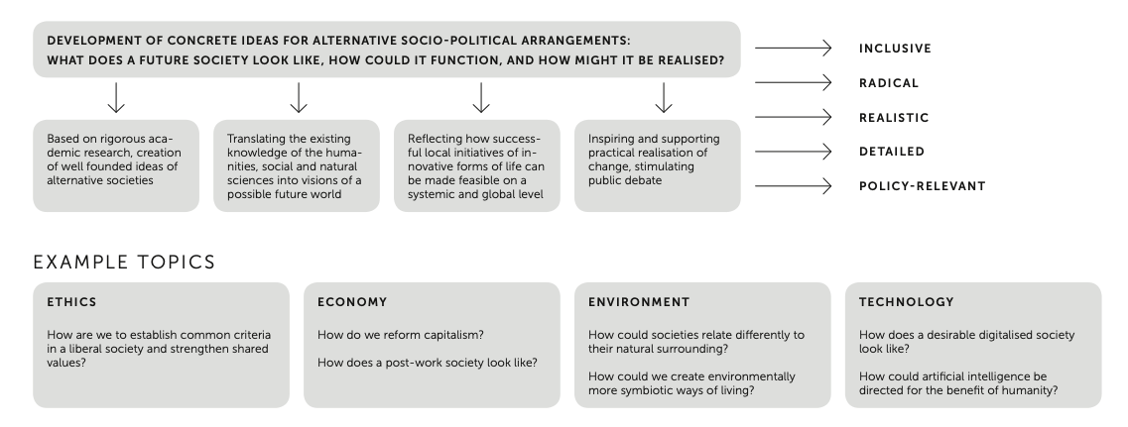

The research program will be organized into two core streams, a visiting fellowship program and a permanent research division. Your post will be based in the latter.

Main Responsibilities

Your main responsibilities will include:

* conceptual development of the specific research topics related to economics
* development of the visiting fellowship program, including identification of candidates for the visiting fellows
* coordination of the appointment process of the fellows
* organization of academic workshops and other events that would facilitate the conceptual development of the Institute
* support of the work of the Institute’s executive board

Please note this role is deemed to be creative and requires a high degree of independence. You will be co-responsible for the further intellectual development of the Institute’s research programme. You will thereby have the opportunity as well as the obligation to determine more definitely through what tasks you could participate in this process most effectively.

Person Profile

|  |  |
| --- | --- |
| **Education and qualification** | A good first degree, and a doctorate in a relevant subject area. |
| **Specialist knowledge and skills** | We are looking for a highly motivated and independent researchers with background in fields such as, but not limited to:   * Economics * Political Economics * Development Economics * Environmental Economics * Economic History * Industrial Organisation * Economics and Law * Development Studies * Anthropology * Sociology   Regardless of the field, close familiarity with one’s own research landscape and relevant academic networks is required.  In addition, candidate should be able to demonstrate interest in at least two of the following:   * Ethics * Technology * Environment |
| **Work experience** | A minimum of one year work experience is highly desirable.  Experiences in organization of academic events, coordination and management of research projects, participation in fellowships programmes, and in science communication are especially welcome. |
| **Interpersonal and communication skills** | Excellent writing skills.  Evidence of ability to organise and participate in collaborative research initiatives. |
| **Language skills** | Fluent knowledge of English required.  Basic knowledge of German highly desirable. |

Terms and Conditions

|  |  |
| --- | --- |
| **Annual (gross) salary** | 42,000-46,000 EUR (depending on the years of experience) |
| **Location** | Hamburg, Germany |
| **Length of appointment** | 2 years. There exists a possibility of extension.  The starting date is as soon as possible. |
| **Probation period** | 6 months |
| **Termination notice** | 3 months (after completion of probation period)  4 week (during probation period) |
| **Annual leave** | 25 days plus public holiday |

Working Permission

If you do not have the right to work in Germany already, any offer of employment will be conditional upon you gaining it. We will assist you in the process of obtaining it.

Application Process

Applicants (m/f/x) are asked to submit a written application consisting of:

* A **Curriculum Vitae**
* A **Cover Letter** (of no more than 2 pages) describing (1) why you are interested in this position; (2) how this position will fit into your longer-term career plans; (3) the connections between your past/ongoing research and the objective and topics of the Institute (4) anything that makes you well-suited to this position; (5) where you saw the job advertised.
* A **Research Proposal** on a specific research topic related to the Institute’s overall objective (1000 words)
* A **Sample of Writing** of no more than 5,000 words. The writing sample may be published work, a chapter from your PhD thesis or a recent monograph, or an unpublished essay/article.
* **References**: In you application provide the names and contact details of two referees who are familiar with your work. Please ask the referees to send their references to jobs@hscif.org.

Apart from references all application material should be sent as **one pdf document** to [jobs@hscif.org](mailto:jobs@hscif.org) by **1 March 2019**.

Shortlisted candidates (m/f/x) will be invited for an either Skype or face-to-face interview to Hamburg. Interviews are planned to be held at the end of March.

General Information

About the Humanities and Social Change International Foundation

The Foundation was founded in 2016 in Hamburg with the mission to understand the nature of the challenges to society of the 21st century, develop visions and concepts that inspire improvement, and actively promote and influence change. The Foundation’s network currently consists of four Research Centers, based respectively at Humboldt University of Berlin; University of California, Santa Barbara; Ca’ Foscari University of Venice; and University of Cambridge. Each Center has its own thematic focus: Crisis of Capitalism and Democracy (Berlin); Technology and Society (Cambridge); Cultural Pluralism (Venice); and ‘Moral and Spiritual Life’ (Santa Barbara). More information about the Foundation and its Centers can be found on [hscif.org](http://hscif.org).

A new Institute in Hamburg

The Foundation is in the process of establishing a new, innovative Institute based in an ensemble of eight classicist townhouses in the center of Hamburg, and aims to open its doors in fall 2020. The overall objective of the Institute will be the development of concrete, innovative concepts for alternative socio-political arrangements. The Institute will form a new interdisciplinary and intercultural environment in which academics and thinkers from politics, technology, business, media and the arts will be gathered to thoroughly engage with each other’s ideas and to conduct collaborative research on specified topics.

The research program will be organized into two core streams, a visiting fellowship program and a permanent research division. Research fellows would work in the latter. The Institute will also have a division whose main task consists in dissemination of research results and public engagement.

Existing and prospective team

The executive board which currently consists of three members with background in academia and business is responsible for the running of the Institute. We are, however, in the process of expanding the executive board, as well as the research and other staff. The hiring of the most suitable candidate (m/w/x) for this position will be made in parallel to the hiring of fellows in the other three key research foci of the Institute, that is in Environment, Ethics and Technology.

Equality and Diversity

HSCIF embraces diversity and equal opportunity in a meaningful way. We are committed to building a team that represents a variety of backgrounds, perspectives, and skills. All employment decisions are made on the basis of qualification, merit, and business needs, but we also believe that the more inclusive we are, the more successful we will be at changing the world. HSCIF welcomes applications from individuals with disabilities.

Data Protection Declaration

We conduct the application process in compliance with applicable data protection law as set out in the General Data Protection Regulation (GDPR) and the German Date Protection Act (BDSG). We have internal policies and controls in place to ensure that your data is not lost, accidentally destroyed, misused or disclosed, and is not accessed except by our employees in the proper performance of their duties.

As part of any recruitment process, HSCIF collects and processes personal data relating to job applicants. HSCIF is committed to being transparent about how it collects and uses that data and to meeting its data protection obligations.

HSCIF may collect a range of information about you. This can include:

* your name, address and contact details, including email address and telephone number;
* details of your qualifications, skills, experience and employment history;
* information about your current level of remuneration, including benefit entitlements;
* information about your entitlement to work in Germany.

HSCIF may collect this information in a variety of ways. For example, data might be contained in application forms, CVs or resumes, obtained from your passport or other identity documents, or collected through interviews. We may also collect personal data about you from third parties, such as references supplied by former employers. Data will be stored in a range of different places, including on your application record, in HR management systems and on other IT systems (including email).

We need to process data to take steps at your request prior to entering into a contract with you. We may also need to process your data to enter into a contract with you. In some cases, we need to process data to ensure that we are complying with its legal obligations. For example, it is mandatory to check a successful applicant's eligibility to work in Germany before employment starts. HSCIF has a legitimate interest in processing personal data during the recruitment process and for keeping records of the process. Processing data from job applicants allows us to manage the recruitment process, assess and confirm a candidate's suitability for employment and decide to whom to offer a job. We may also need to process data from job applicants to respond to and defend against legal claims. We process such information to carry out its obligations and exercise specific rights in relation to employment. If your application is unsuccessful, HSCIF may keep your personal data on file in case there are future employment opportunities for which you may be suited. We will ask for your consent before we will keeps your data for this purpose and you are free to withdraw your consent at any time.

Your information may be shared internally for the purposes of the recruitment exercise. This includes members of the HR and recruitment team, interviewers involved in the recruitment process, managers in the business area with a vacancy and IT staff if access to the data is necessary for the performance of their roles.

If your application for employment is unsuccessful, HSCIF will hold your data on file for 6 (six) months after the end of the relevant recruitment process. If you agree to allow us to keep your personal data on file, we will hold your data on file for a further 6 (six) months for consideration for future employment opportunities. At the end of that period, or once you withdraw your consent, your data is deleted or destroyed. You will be asked when you submit your CV whether you give us consent to hold your details for the full 12 months in order to be considered for other positions or not. If your application for employment is successful, personal data gathered during the recruitment process will be transferred to your Human Resources file (electronic and paper based) and retained during your employment. The periods for which your data will be held will be provided to you in a new privacy notice.

As a data subject, you have a number of rights. You can:

* access and obtain a copy of your data on request;
* require the HSCIF to change incorrect or incomplete data;
* require the HSCIF to delete or stop processing your data, for example where the data is no longer necessary for the purposes of processing; and
* object to the processing of your data where HSCIF is relying on its legitimate interests as the legal ground for processing.

If you would like to exercise any of these rights, please contact [nina.rismal@hscif.org](mailto:nina.rismal@hscif.org).

You are under no statutory or contractual obligation to provide data to HSCIF during the recruitment process. However, if you do not provide the information, we may not be able to process your application properly or at all.

Contact person

If you have questions about the position, please contact [nina.rismal@hscif.org](mailto:nina.rismal@hscif.org).